create view `Students.v4_Vitalii_modul_task` as

-- Підготовка даних по акаунтах

with account as (

SELECT

s.date date,

sp.country as country,

a.send_interval send_interval,

a.is_verified is_verified,

a.is_unsubscribed is_unsubscribed,

count(distinct a.id) as acc_cnt

FROM `DA.account` a

join `DA.account_session` acs

on a.id = acs.account_id

JOIN `DA.session` s

on s.ga_session_id = acs.ga_session_id

JOIN `DA.session_params` sp

on sp.ga_session_id = s.ga_session_id

group by

s.date,

sp.country,

a.send_interval,

a.is_verified,

a.is_unsubscribed

),

email_metrics as (

SELECT

date_add(s.date, interval es.sent_date day) as date,

sp.country country ,

a.send_interval send_interval,

a.is_verified is_verified,

a.is_unsubscribed is_unsubscribed,

COUNT(DISTINCT es.id_message) AS sent_msg,

COUNT(DISTINCT eo.id_message) AS open_msg,

COUNT(DISTINCT ev.id_message ) AS visit_msg

FROM

`DA.email_sent` es

left join `DA.email_open` eo

on eo.id_message = es.id_message

left join `DA.email_visit` ev

on ev.id_message = es.id_message

join `DA.account_session` acs

on es.id_account = acs.account_id

join `DA.session` s

on s.ga_session_id = acs.ga_session_id

join `DA.session_params` sp

on sp.ga_session_id = acs.ga_session_id

join `DA.account` a

on a.id =es.id_account

group by

date_add(s.date, interval es.sent_date day),

sp.country,

a.send_interval,

a.is_verified,

a.is_unsubscribed

),

--обєднання данних двох вище вказаних таблиць

unions as (

SELECT

date,

country,

send_interval,

is_verified,

is_unsubscribed,

acc_cnt,

0 as sent_msg,

0 as open_msg,

0 as visit_msg

FROM account

union all

SELECT

date,

country,

send_interval,

is_verified,

is_unsubscribed,

0 as acc_cnt,

sent_msg,

open_msg,

visit_msg

FROM

email_metrics

),

--сумування значень по листам та прибирання "0" після юніна

final_data as (

SELECT

date,

country,

send_interval,

is_verified,

is_unsubscribed,

sum(acc_cnt) account_cnt,

sum(sent_msg) as sent_msg,

sum(open_msg) as open_msg,

sum(visit_msg) as visit_msg

FROM unions

group by

date,

country,

send_interval,

is_verified,

is_unsubscribed

),

-- обчислення акаунтів та відправлених повідомлень, ранг по кожній країні

final_sums as (

SELECT *,

dense_RANK() OVER (ORDER BY total_country_account_cnt DESC) AS rank_total_country_account_cnt,

dense_RANK() OVER (ORDER BY total_country_sent_cnt DESC) AS rank_total_country_sent_cnt

FROM (

SELECT *,

SUM (account_cnt) OVER (PARTITION BY country) AS total_country_account_cnt,

SUM (sent_msg) OVER (PARTITION BY country) AS total_country_sent_cnt,

FROM final_data

)

)

--кінцева таблиця з фільтрацією даних по рангу

SELECT

date,

country,

send_interval,

is_verified,

is_unsubscribed,

account_cnt,

sent_msg,

open_msg,

visit_msg,

total_country_account_cnt,

total_country_sent_cnt,

rank_total_country_account_cnt,

rank_total_country_sent_cnt

FROM final_sums

where

rank_total_country_account_cnt <= 10

or

rank_total_country_sent_cnt <= 10

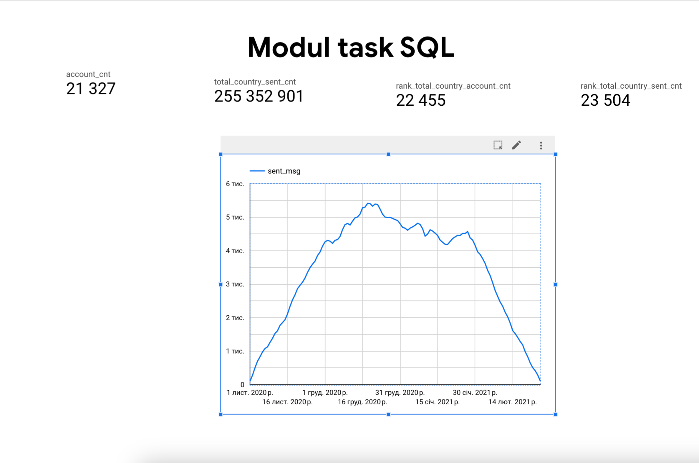

<https://docs.google.com/document/d/1VG2koUE6_jKGndzoEb4Ji5lu1fmbosXkI060TiHorY4/edit?usp=drive_link>